SPCM lab 12

Khushi chauhan

Devops b1 h

500105956

Creating Static Host Inventory

Objective: To create a static host inventory for managing and automating infrastructure tasks efficiently across multiple servers using Ansible

Tools required: Ubuntu OS Prerequisites: You need to have Ansible installed to proceed with this demo

Steps to be followed:

1. Generate SSH key pair on the main node

2. Copy the SSH key to the two other nodes

3. Update the inventory or host file with the host IP address

4. Establish connectivity between the hosts specified in the host file and the Ansible server

First we need to start 3 Amazon Linux machines

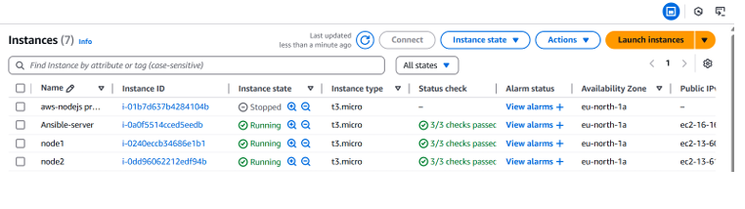

For all 3 machines - Make user for all by using command – ‘sudo su’ Add user by using ‘adduser’ Password by adding ‘passwd ’ --enterpassword

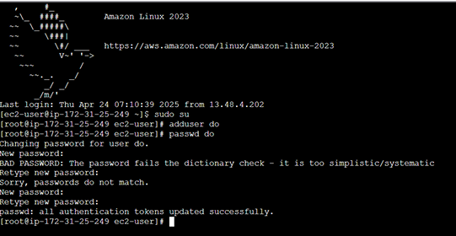

To make as root user open vi.sudo file command – ‘vi.sudo’ ‘do ALL=(ALL) NOPASSWD:ALL’

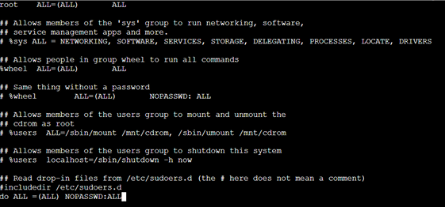

Now to switch to user from root user use ‘su – do’

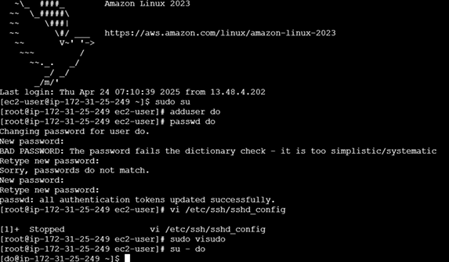

Similarly, for node 1 –

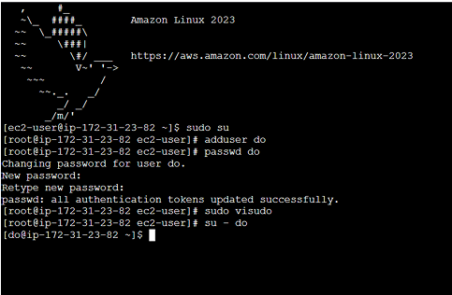

Node 2 –

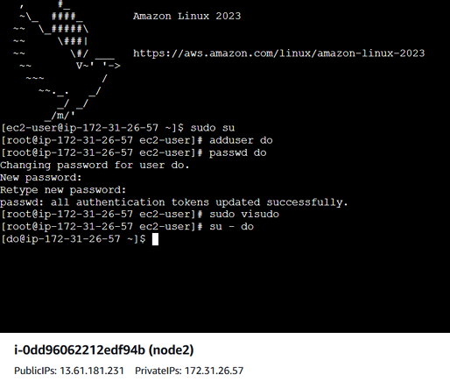

Now trying to ssh into node 1 from Ansible server

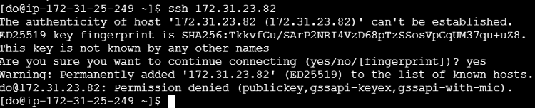

Permission denied. So,make settings in node 1 and node 2 to allow. Go to root user of node 1 and node 2 by ‘sudo su’ Navigate to ‘vi /etc/ssh/sshd_config’ and uncomment permit root login and comment PasswordAuthentication Restart the service using ‘service sshd restart’

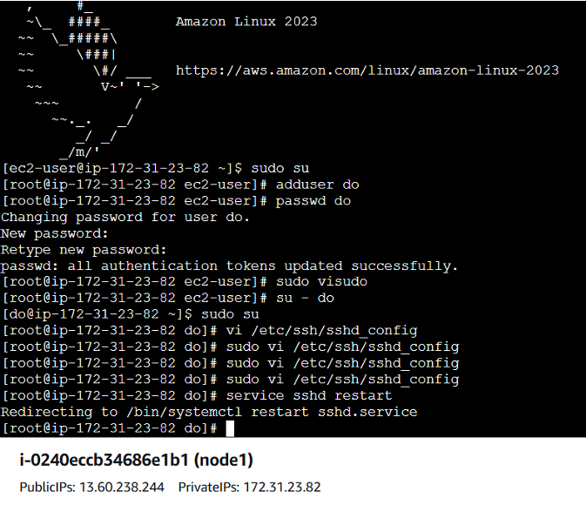

Repeat the process for node 2

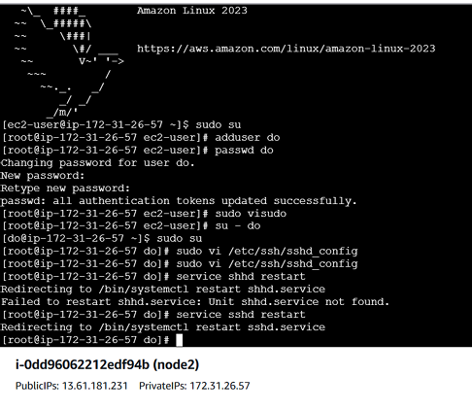

Now again from Ansible server trying to ‘ssh ’

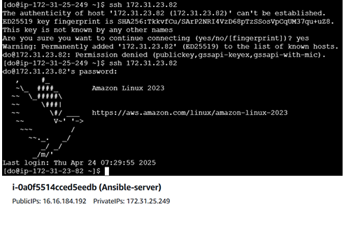

Similarly ‘ssh ’

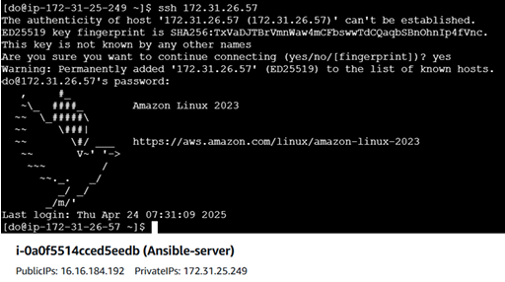

This technique works only for 1 machine at a time, but we need parallel firing of commands for multiple machines.

Step 1: Generate SSH key pair on the main node

1.1 Use the following command to generate the SSH key on the Ansible server: ssh-keygen

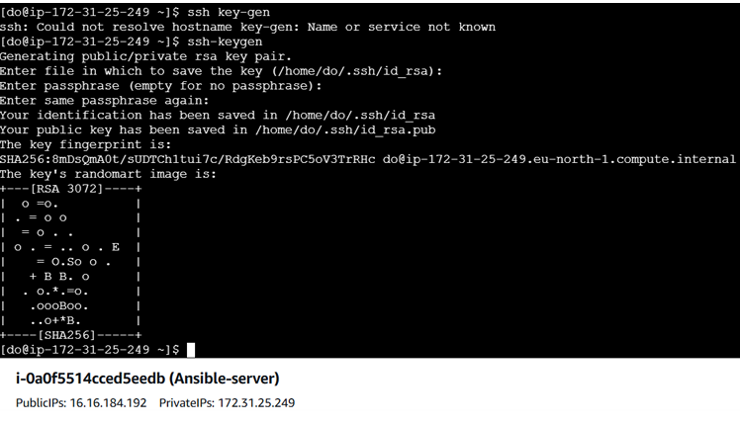

Step 2: Copy the SSH key to the other two nodes 2.1 Use the following command to copy the public key to a file named authorized_keys in localhost: cat .ssh/id_rsa.pub >> .ssh/authorized_keys 2.2 Run the following command to go to the .ssh directory of the Ansible server: cd .ssh

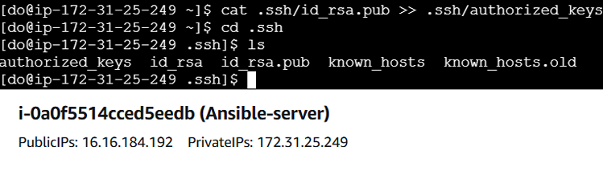

2.3 Run the following command to copy the public key to another node that will connect to the Ansible server: ssh-copy-id username@ip -p 22

For node 1 -

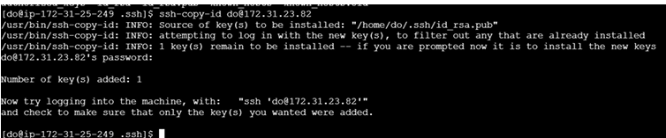

For node 2 -

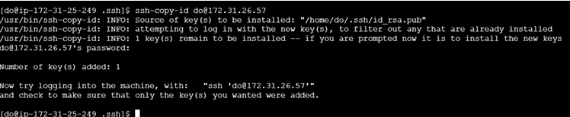

Note: You must use a username@ip with your node and IP username, which are provided in the lab credential.

2.4 Execute the following command to exit the .ssh directory of the Ansible server: cd

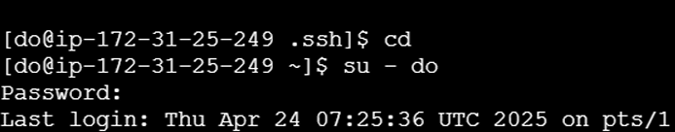

Install Ansible on ansible server Use commands ‘sudo yum update -y’ and ‘sudo yum install ansible -y’

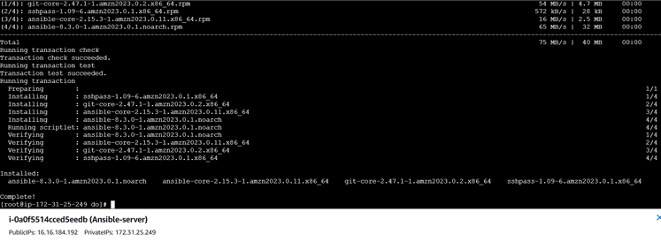

To check Ansible version use ‘ansible --version’

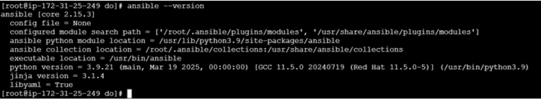

Step 3: Update the inventory or host file with the host IP address

3.1 Use the following command to open the Ansible inventory file and add the host localhost to it: sudo vi /etc/ansible/hosts



3.2 When the file opens, add the three lines of code below to the end of the file: [dbbservers] localhost:22 172.31.5.76:22

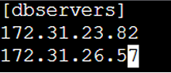

Step 4: Establish connectivity between the hosts specified in the host file and the Ansible server

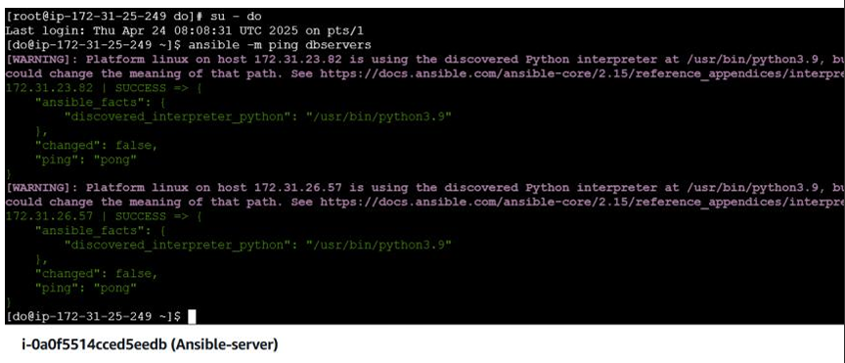

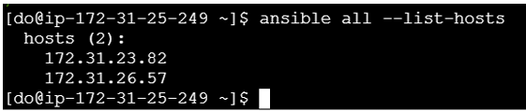

By following these steps, you have successfully created a static host inventory for managing and automating infrastructure tasks efficiently across multiple servers using Ansible.